9.31: (a) For a given radius and mass, the force is proportional to the square of the angular velocity; 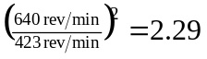 (note that conversion to 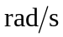 is not necessary for this part). b) For a given radius, the tangential speed is proportional to the angular velocity; 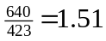 (again conversion of the units of angular speed is not necessary).
c) (640 to three figures, and 